CountEmissions EU supports our industry’s ambition for more GHG emission transparency and sustainable transport decision making.
Cefic considers the EU Commission's proposal for the CountEmissions EU Regulation as a significant step forward in supporting the transport & logistics industry to reduce emissions. We believe that the implementation of effective market-based tools and support mechanisms is essential. The Commission's introduction of a unified methodology comes at the right time. This methodology allows transport operators to accurately calculate, monitor and compare their emissions. It provides a common framework which will help companies creating sustainable transport strategies.
The issue
Since 2022, Cefic’s SQAS assessment scheme supports our members to verify emission measuring and managing of our chemicals logistics service providers. First results show that 70% of the assessed logistics companies is able to collect primary data from own assets, but only 40% is collecting data from subcontracted services. Only 35% of the transport & logistics service providers is able to calculate an energy based emission intensity of their operations. This analysis shows that a combined action from shippers (the customer) and EU Regulation is needed to support the logistics market in learning how to measure and in becoming more transparent towards customers.
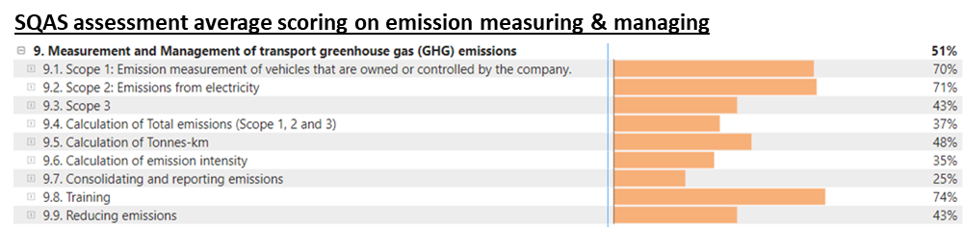
What is at stake for the chemical industry
The European chemical sector accounts for approximately 10 million tons GHG emissions from transport. Cefic Members are active since years to develop emissions reduction strategies, collaborating with their respective contractors and subcontractors, as they are finally responsible for a significant portion of direct emissions. However, chemicals logistics processes doesn’t only cover transport. Also cleaning or heating operations are part of the chemicals supply chain. Their impact is significant : a typical cleaning operation emits 86,6 kg CO2e, which is higher than the emissions of 1000 tonkm road transport! Therefor, detailed understanding of all transport & logistics emissions, based on real fuel consumption, will be crucial to make sustainable supply chain decisions.
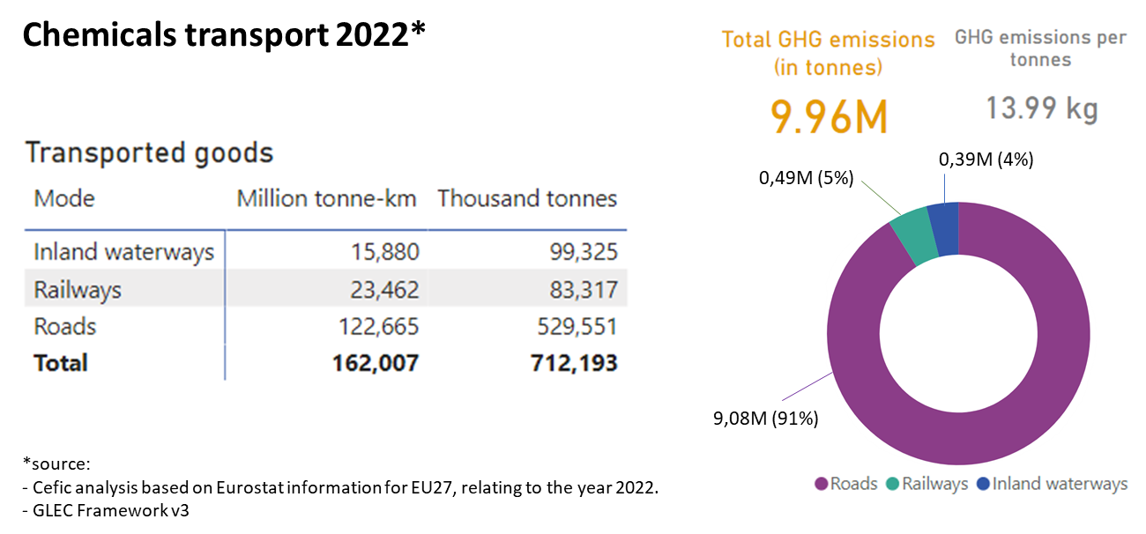
Key challenges
- Cefic supports the Commission's proposal for a common methodology based on the ISO 14083 standard. However, it remains important to continuously monitor other valuable sources and references which are consolidated in the market and may offer more accurate guidance for GHG emissions calculation and reporting.
- The use of primary data should be encouraged as much as possible to ensure more precise calculations. This allows transport emission reduction initiatives by the logistics service provider to be reflected in their emission intensity report. Cefic invites the EU institutions to evaluate financed initiatives to enable an easy collection of primary data.
- The “binding opt-in” base for reporting, in particular for SMEs, should be maintained allowing companies to become accustomed to the framework and ISO standard. This approach should be seen as a proactive support for companies to learn and implement calculation based on primary data. All freight transport stakeholders must first acquire know-how, investment, organization and technology without a mandatory requirement which would force them to use secondary data or averages. Emission intensity data of a logistics company should be treated as confidential business information and not be mandated to be disclosed to the public.
- Cefic supports the use of default values from third-party providers. Cefic can also bring expertise for chemicals transport default values as published in the GLEC framework. This includes typical chemicals logistics payload averages, empty runs,… and chemicals transport operations categories (pipeline transport, single wagon transport, cleaning, heating,…)
- This regulation should enter into force 18 months after adoption. After 5 years, an revision could be considered to make measuring and reporting, based on primary data, mandatory. The proposal could then be further extended with a clear data collection and exchange framework, in connection with the Electronic Freight Transport Information (eFTI) platforms.
Proposed solutions
- Crucial use of primary data
  - To ensure accurate GHG emissions reporting, it is crucial to have access to and use data obtained through direct fuel and tonkm measurements. While secondary and default data, including third-party default values, are valuable, stakeholders should prioritize primary data whenever possible. Data used and reported should accurately reflect real-world conditions, and Cefic has promoted these principles through the logistics chain via SQAS.
  - Cefic supports the creation of an EU database for default values that should consider sector-specific differences and remain neutral towards all fuels. This database should serve as a common reference to ensure a shared understanding. Cefic, in collaboration with the Smart Freight Centre, has developed "GLEC - Module 5," which provides GHG default values for the Chemical Industry based on global, regional, or country-level sources.
  - Implementing quality checks for third-party data providers is essential to make their datasets and services more accessible and reliable. The ultimate goal is to transition from default data to using primary data for precise GHG reporting. Reliable data plays a critical role in making informed modal shift and transport decisions, potentially influencing EU or national support programs.
- Base Methodology
  - Cefic supports the Commission's adoption of the ISO 14083 standard for calculating transport emissions in the CountEmissions EU initiative. Cefic has actively contributed to initiatives prioritizing greenhouse gas (GHG) emissions calculation and reporting in freight and logistics. Our ongoing commitment has led to the publication of "GLEC Module 5" in collaboration with Smart Freight Centre and sector-specific guidelines for "Emissions Calculation," currently undergoing revision to provide practical guidance.
  - Cefic urges EU Institutions, particularly when drafting secondary legislation, to incorporate core principles from existing methodologies for smoother market acceptance and harmonization. We also recommend the inclusion of various sector-specific stakeholders in the development of effective guidelines, fostering collaboration and practical solutions.
- Binding opt-in approach
  - Cefic emphasizes the importance of an “opt-in” approach for GHG emissions accounting, making it accessible for both Corporations and SMEs. The voluntary nature of GHG emissions data reporting, allows the industry and particularly SMEs to gradually align.
  - Cefic appreciates the exemption of SMEs from verification duties, allowing them time to invest in and develop tools and practices that meet expectations.
  - The Chemical Industry has been collaborating with logistics partners for years to ensure accurate reporting and primary data. Cefic highlights that the SQAS assessment scheme guides logistics partners toward generating primary data, striving to minimize the use of averages and activity-based data. This ongoing journey with chemical companies and logistics service providers requires time, both technically and in terms of market development. The ultimate goal, as proposed, is to achieve accurate, reliable, and verified primary data.
  - Cefic suggests the EU Institutions and particularly the EU Commission, to consider further industry incentives to promote GHG emissions primary data reporting.
- Secondary Legislation
  - The proposal grants the Commission considerable authority to create technical rules and specifications through delegated and implementing acts. Cefic stresses the importance of involving sectorial stakeholders to bring their practical input and contribute to the act development and to closely monitoring and supporting the Commission in developing necessary technical specifications.
  - Cefic acknowledges the need to avoid burdening companies with overly stringent administrative procedures, especially in the context of "conformity assessment" for reporting. Cefic encourages EU Institutions to strike a balance that recognizes and rewards companies that have already made investments in compliance with primary data reporting.
Conclusion
Cefic fully supports the CountEmissions EU initiative, aiming to create a unified framework for calculating transport and logistics emissions in the EU. We believe that this act will enhance the reliability of emissions data and encourage its use in business practices. Cefic also emphasizes the importance of accurate GHG emissions reporting in connection of the other legislation which is part of the “Greening freight package”, such as the revision of the Combined Transport Directive and the Weight and Dimensions Directive.

Contact: Joost Naessens, Director Transport & Logistics, +32 473 64 65 57, jna@cefic.be

www.sqas.org

